**Chap 6: PERFECT COMPETITION**

1. **Defination of perfectly competitive market**

Perfectly competitive market (thị trường cạnh tranh hoàn hảo) is the maket that has following factors:

* Many sellers and buyers. All of them are price taker.
* The same products or homogeneous (giống nhau)
* Free entry and exit

1. **Price taker and demand curve of firm**

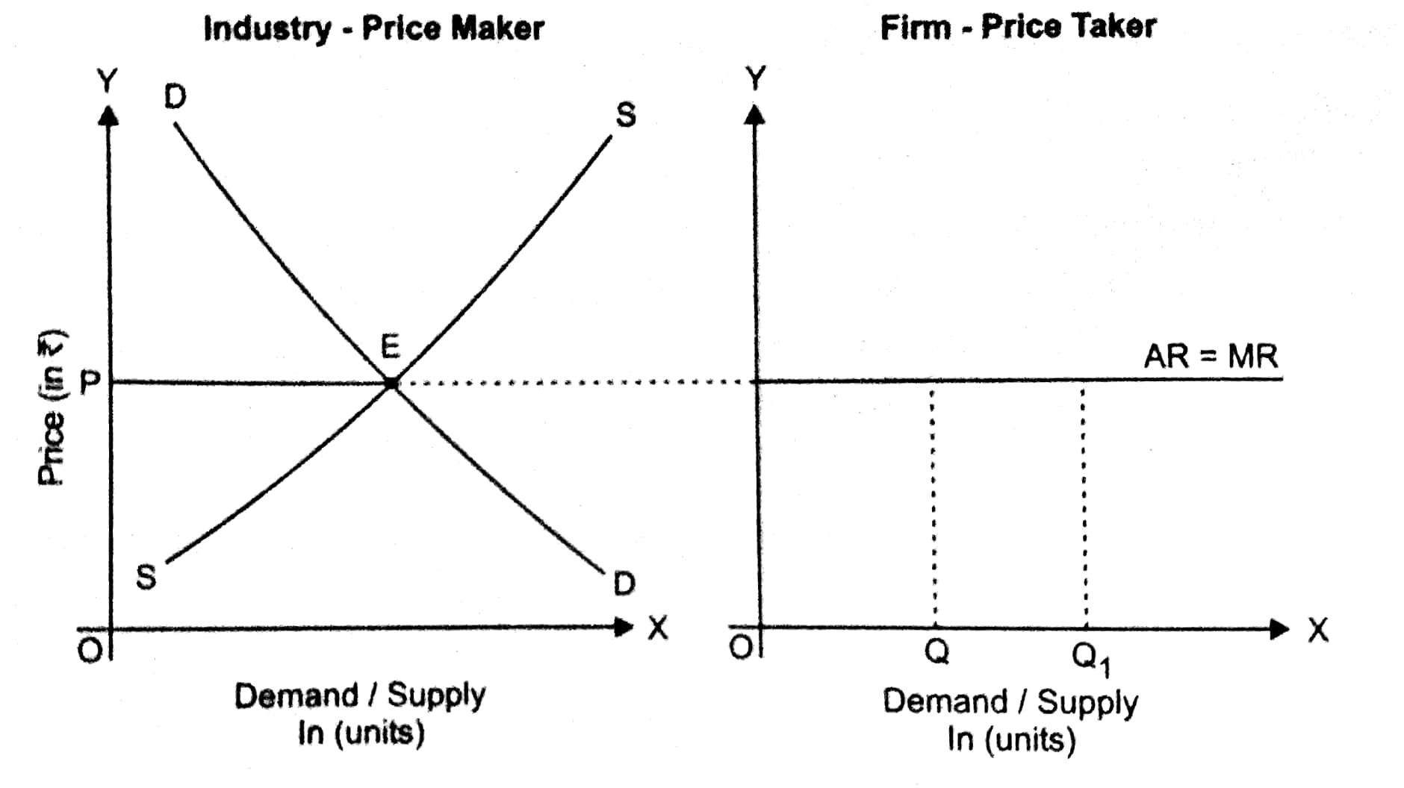

* Mức giá sẽ do thị trường quyết định, đường cầu của doanh nghiệp nằm ngang ứng với mức giá đó.
* Doanh nghiệp chỉ có thể điều chỉnh sản lượng bán ra, không thay đổi được giá do tính cạnh tranh cao.

1. **Time period in Economics**

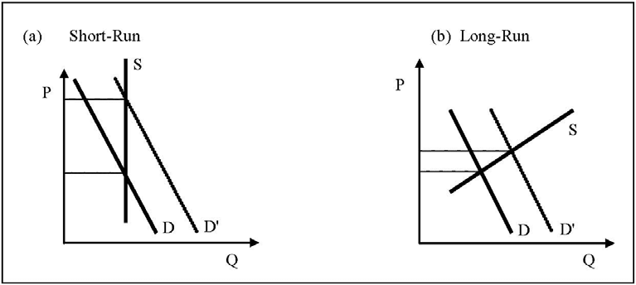

* In short-run, respond to supply is low, so, output is fix, the supply curve is a verticle line.
* In long-run, respond to supply is significantly, output can change, the supply curve is upward sloping.

1. **Short-run supply by a price-taking firm**

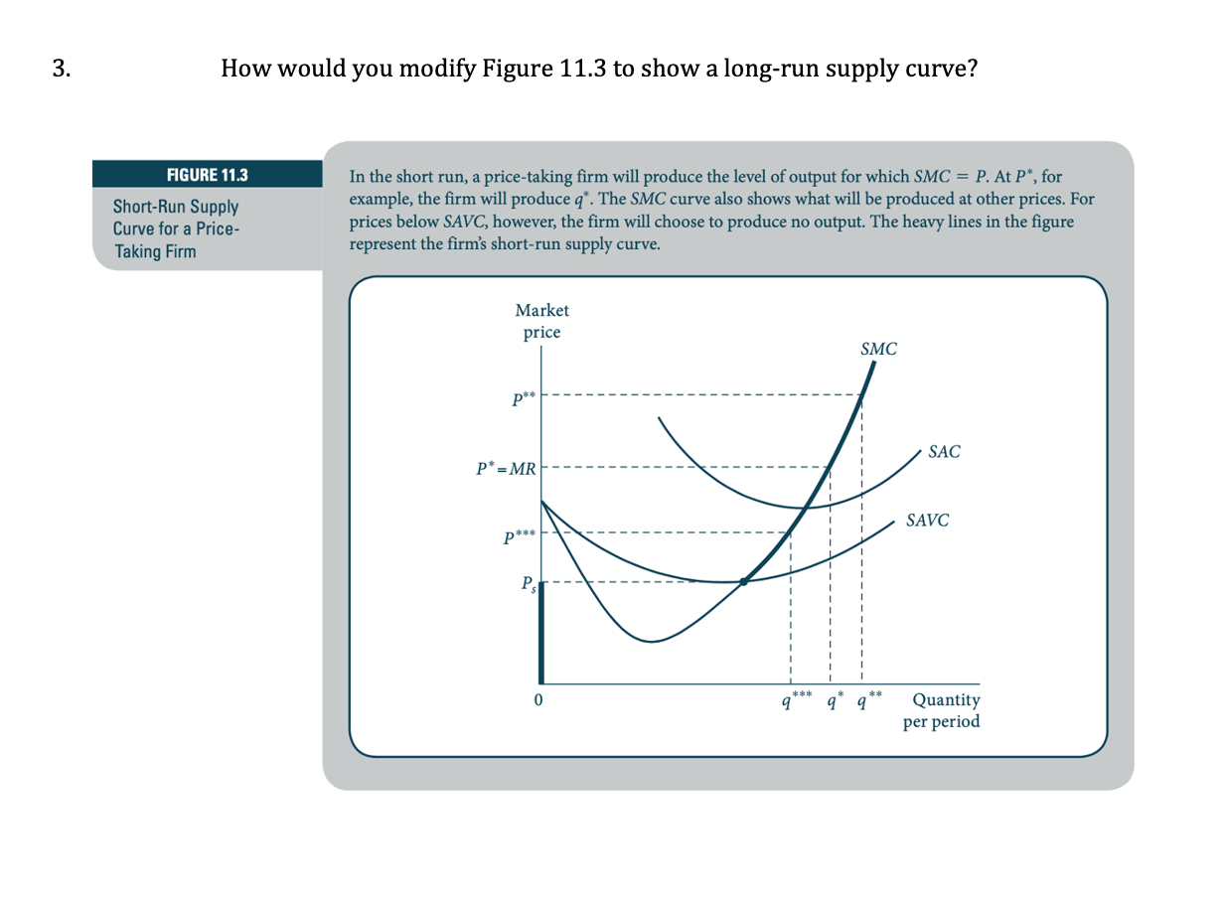

* In short-run, the part of SMC curve that above SAVC min is the short-run supply curve of firm.
* If: **P<AVCmin** => the firm should shut down (produce no output)

**AVCmin<P<SAC** => the firm should continue to produce to cover fixed cost.

**P>SAC** => the firm will gain positive profit.